AZURE VIRTUAL MACHINES:

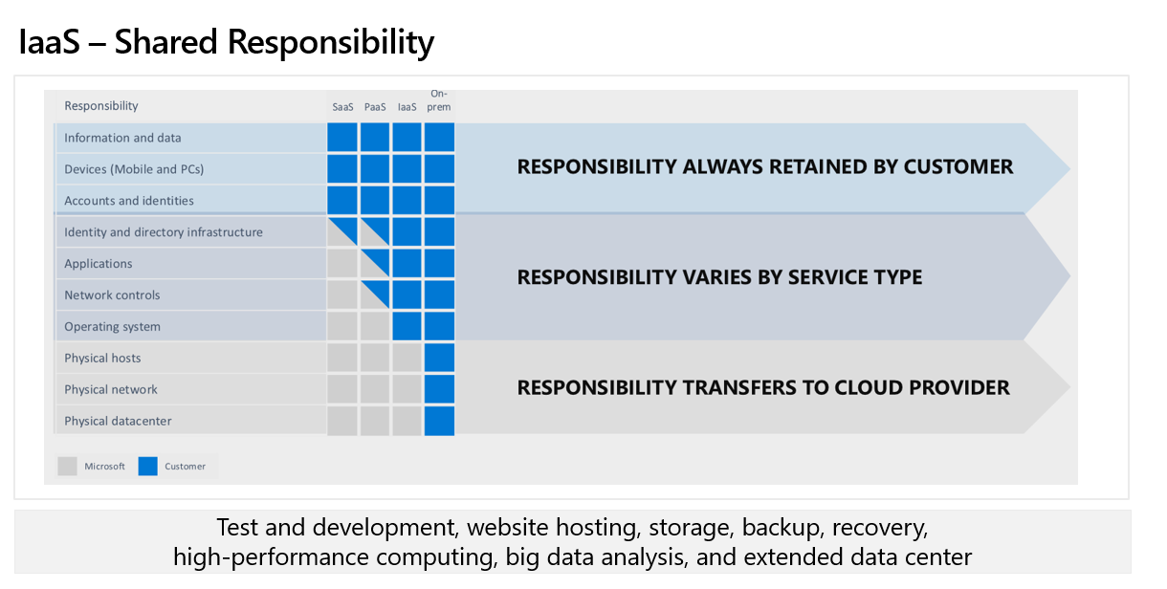

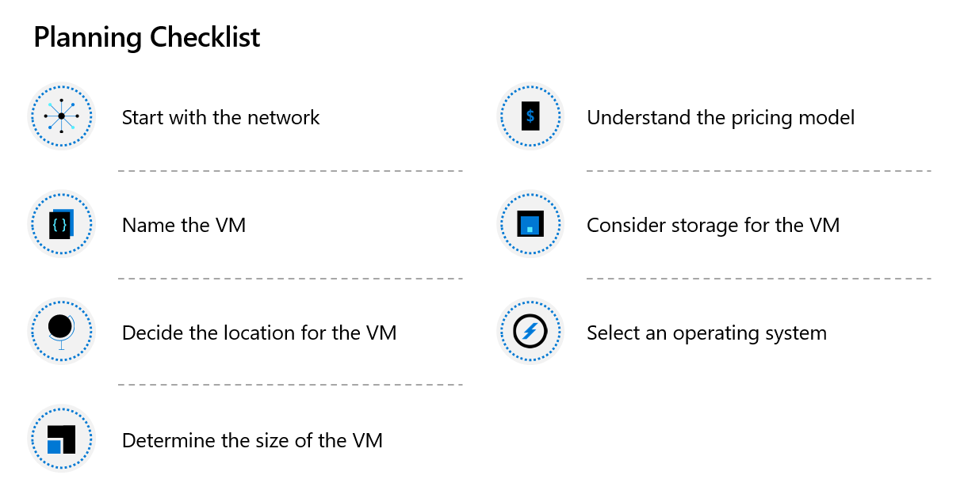

USE CASES FOR DIFFERENT SIZE OF SERVERS:

A Series - Entry-level for dev/test - [ Used for Dev and test servers]
B series – Economical Burstable VMs – [ Used for Small databases]
D series – General Purpose Compute – [ Better Local disk performance]
Dc series – Protect data in use – [ Confidential querying in databases]
E series – Used for SAP HANA, SAP S/4 HANA and other large in memory business critical workloads]
F series – [ Used for Batch processing, web servers]
G series – [ LARGE SQL and NOSQL databses]
H series – [ Used for spark, weather modelling]
L series – [ Used for NoSQL Databases such as Cassandra, MongoDB]
M and Mv2 – [Used for SAP HANA, SAP S/4 HANA]
N series – [Used for graphics rendering, remote visualization]

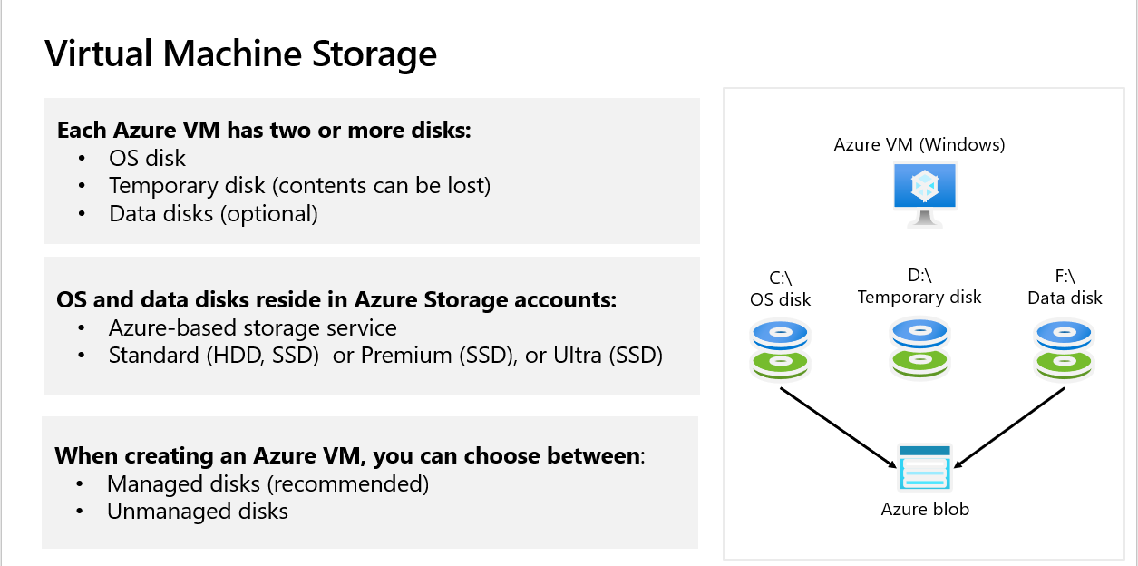

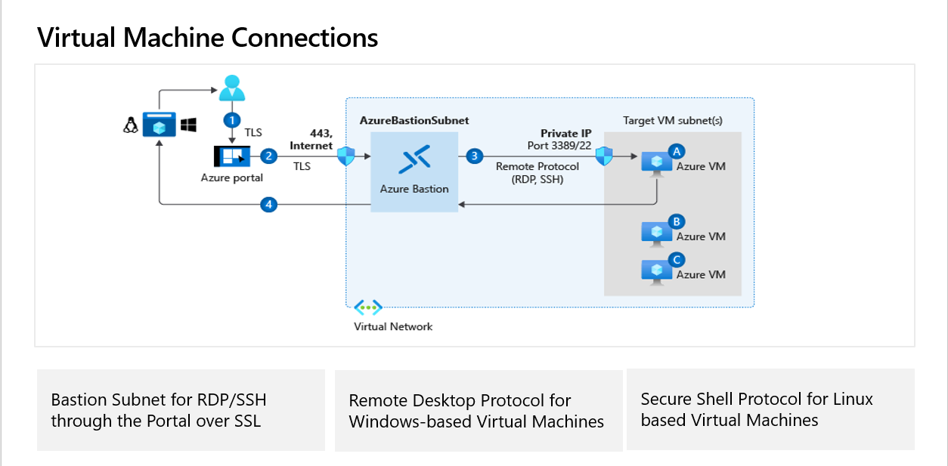

What is an availability set?
An availability set is a logical grouping of VMs that allows Azure to understand how your application is built to provide for redundancy and availability. We recommended that two or more VMs are created within an availability set to provide for a highly available application and to meet the 99.95% Azure SLA. There is no cost for the Availability Set itself, you only pay for each VM instance that you create.

How do availability sets work?
Each virtual machine in your availability set is assigned an update domain and a fault domain by the underlying Azure platform. Each availability set can be configured with up to three fault domains and twenty update domains. Update domains indicate groups of virtual machines and underlying physical hardware that can be rebooted at the same time. When more than five virtual machines are configured within a single availability set, the sixth virtual machine is placed into the same update domain as the first virtual machine, the seventh in the same update domain as the second virtual machine, and so on. The order of update domains being rebooted may not proceed sequentially during planned maintenance, but only one update domain is rebooted at a time. A rebooted update domain is given 30 minutes to recover before maintenance is initiated on a different update domain.
Fault domains define the group of virtual machines that share a common power source and network switch. By default, the virtual machines configured within your availability set are separated across up to three fault domains. While placing your virtual machines into an availability set does not protect your application from operating system or application-specific failures, it does limit the impact of potential physical hardware failures, network outages, or power interruptions.
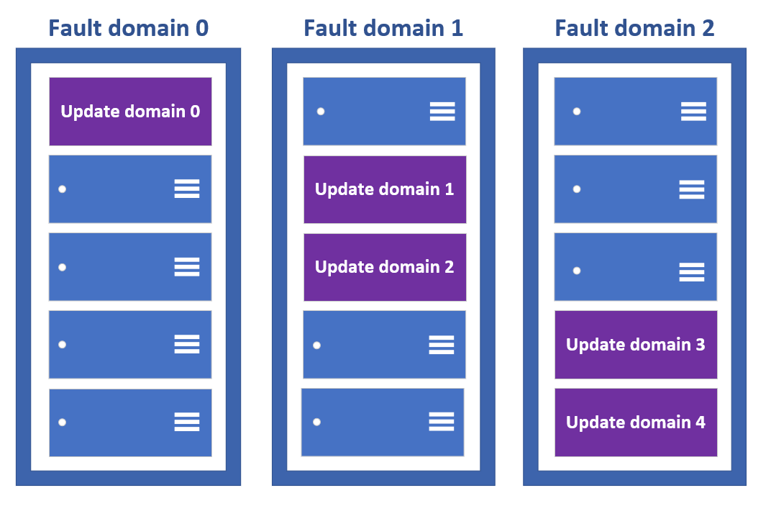
VMs are also aligned with disk fault domains. This alignment ensures that all the managed disks attached to a VM are within the same fault domains.
Only VMs with managed disks can be created in a managed availability set. The number of managed disk fault domains varies by region - either two or three managed disk fault domains per region.

Availability Zones
An Availability Zone is a high-availability offering that protects your applications and data from datacenter failures. Availability Zones are unique physical locations within an Azure region. Each zone is made up of one or more datacenters equipped with independent power, cooling, and networking. To ensure resiliency, there's a minimum of three separate zones in all enabled regions. The physical separation of Availability Zones within a region protects applications and data from datacenter failures. Zone-redundant services replicate your applications and data across Availability Zones to protect from single-points-of-failure. With Availability Zones, Azure offers industry best 99.99% VM uptime SLA. The full Azure SLA explains the guaranteed availability of Azure as a whole.
An Availability Zone in an Azure region is a combination of a fault domain and an update domain. For example, if you create three or more VMs across three zones in an Azure region, your VMs are effectively distributed across three fault domains and three update domains. The Azure platform recognizes this distribution across update domains to make sure that VMs in different zones are not scheduled to be updated at the same time.
Build high-availability into your application architecture by co-locating your compute, storage, networking, and data resources within a zone and replicating in other zones. Azure services that support Availability Zones fall into two categories:
- Zonal services – where a resource is pinned to a specific zone (for example, virtual machines, managed disks, Standard IP addresses), or
- Zone-redundant services – when the Azure platform replicates automatically across zones (for example, zone-redundant storage, SQL Database).
To achieve comprehensive business continuity on Azure, build your application architecture using the combination of Availability Zones with Azure region pairs. You can synchronously replicate your applications and data using Availability Zones within an Azure region for high-availability and asynchronously replicate across Azure regions for disaster recovery protection.

Virtual Machine Scale Sets:
Azure virtual machine scale sets let you create and manage a group of load balanced VMs. The number of VM instances can automatically increase or decrease in response to demand or a defined schedule. Scale sets provide high availability to your applications, and allow you to centrally manage, configure, and update a large number of VMs. With virtual machine scale sets, you can build large-scale services for areas such as compute, big data, and container workloads.

Why use virtual machine scale sets?
To provide redundancy and improved performance, applications are typically distributed across multiple instances. Customers may access your application through a load balancer that distributes requests to one of the application instances. If you need to perform maintenance or update an application instance, your customers must be distributed to another available application instance. To keep up with extra customer demand, you may need to increase the number of application instances that run your application.
Azure virtual machine scale sets provide the management capabilities for applications that run across many VMs, automatic scaling of resources, and load balancing of traffic. Scale sets provide the following key benefits:
- Easy to create and manage multiple VMs
  - When you have many VMs that run your application, it's important to maintain a consistent configuration across your environment. For reliable performance of your application, the VM size, disk configuration, and application installs should match across all VMs.
  - With scale sets, all VM instances are created from the same base OS image and configuration. This approach lets you easily manage hundreds of VMs without extra configuration tasks or network management.
  - Scale sets support the use of the Azure load balancer for basic layer-4 traffic distribution, and Azure Application Gateway for more advanced layer-7 traffic distribution and TLS termination.
- Provides high availability and application resiliency
  - Scale sets are used to run multiple instances of your application. If one of these VM instances has a problem, customers continue to access your application through one of the other VM instances with minimal interruption.
  - For more availability, you can use Availability Zones to automatically distribute VM instances in a scale set within a single datacenter or across multiple datacenters.
- Allows your application to automatically scale as resource demand changes
  - Customer demand for your application may change throughout the day or week. To match customer demand, scale sets can automatically increase the number of VM instances as application demand increases, then reduce the number of VM instances as demand decreases.
  - Autoscale also minimizes the number of unnecessary VM instances that run your application when demand is low, while customers continue to receive an acceptable level of performance as demand grows and additional VM instances are automatically added. This ability helps reduce costs and efficiently create Azure resources as required.
- Works at large-scale
  - Scale sets support up to 1,000 VM instances for standard marketplace images and custom images through the Shared Image Gallery. If you create a scale set using a managed image, the limit is 600 VM instances.
  - For the best performance with production workloads, use Azure Managed Disks.

AZURE VIRTUAL MACHINE EXTENSIONS:
Azure virtual machine (VM) extensions are small applications that provide post-deployment configuration and automation tasks on Azure VMs. For example, if a virtual machine requires software installation, anti-virus protection, or to run a script inside of it, a VM extension can be used. Azure VM extensions can be run with the Azure CLI, PowerShell, Azure Resource Manager templates, and the Azure portal. Extensions can be bundled with a new VM deployment, or run against any existing system.
This article provides an overview of VM extensions, prerequisites for using Azure VM extensions, and guidance on how to detect, manage, and remove VM extensions. This article provides generalized information because many VM extensions are available, each with a potentially unique configuration. Extension-specific details can be found in each document specific to the individual extension.

Use cases and samples
Several different Azure VM extensions are available, each with a specific use case. Some examples include:
- Apply PowerShell Desired State configurations to a VM with the DSC extension for Windows. For more information, see Azure Desired State configuration extension.
- Configure monitoring of a VM with the Log Analytics Agent VM extension. For more information, see Connect Azure VMs to Azure Monitor logs.
- Configure an Azure VM by using Chef. For more information, see Automating Azure VM deployment with Chef.
- Configure monitoring of your Azure infrastructure with the Datadog extension. For more information, see the Datadog blog.
In addition to process-specific extensions, a Custom Script extension is available for both Windows and Linux virtual machines. The Custom Script extension for Windows allows any PowerShell script to be run on a VM. Custom scripts are useful for designing Azure deployments that require configuration beyond what native Azure tooling can provide. For more information, see Windows VM Custom Script extension.

